0.project-It is the root element of the pom.xml file.
- modelVersion-modelversion means what version of the POM model you are using. Use version 4.0.0 for maven 2 and maven 3.
- groupId-groupId means the id for the project group. It is unique and Most often you will use a group ID which is similar to the root Java package name of the project like we used the groupId com.project.loggerapi.
- artifactId-artifactId used to give name of the project you are building.in our example name of our project is LoggerApi.
- version-version element contains the version number of the project. If your project has been released in different versions then it is useful to give version of your project.

Dependencies and Repositories:Dependencies are external Java libraries required for Project and repositories are directories of packaged JAR files. The local repository is just a directory on your machine hard drive. If the dependencies are not found in the local Maven repository, Maven downloads them from a central Maven repository and puts them in your local repository.

Plugin Vs Dependencies
plugin is a Jar file which executes the task, and dependency is a Jar which provides the class files to execute the task.

Working of WebDriver

It uses an analogy with taxi driving.
Selenium webdriver driver a browser the same way taxi driver drives a cab .
In taxi driving, there are typically 3 actors:
- the client he tells the taxi driver where he wants to go and how to get there
- the taxi driver he executes the client's requests; the taxi driver sends his own requests to the car
- the car the car executes the taxi driver's requests

The client gets to the destination through dialogues that happen between the client - taxi driver and taxi driver - car.
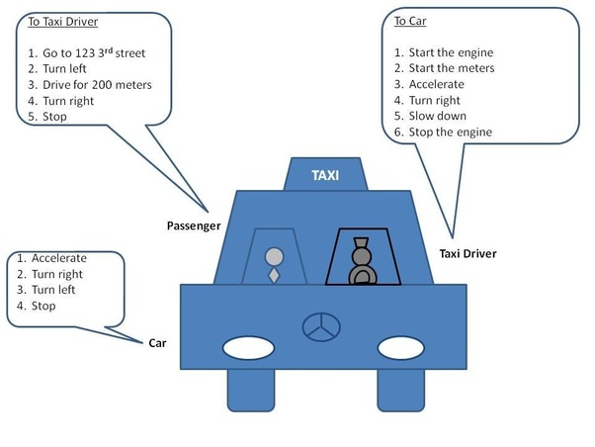

WebDriver Arct.

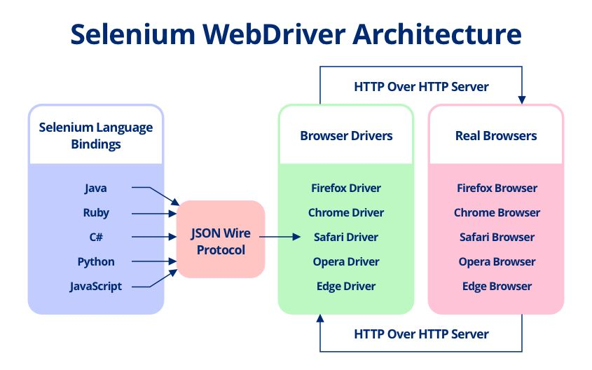

Selenium WebDriver API provides communication facility between languages and browsers

What’s the Difference Between TDD and BDD?
In TDD (Test Driven Development), the test is written to check the implementation of functionality, but as the code evolves, tests can give false results. BDD (Behavior Driven Development) is also a test-first approach, but differs by testing the actual behavior of the system from the end users perspective.

